Tourist management system

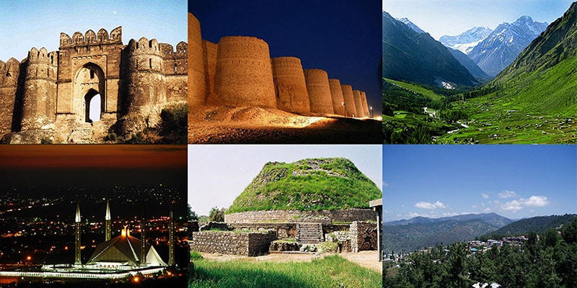REPORT SUBTITLE

Database development | | 26-dec-2018

Submitted to: DR.KHURAM SHAHZAD

Submitted by: M.SAQIB NADEEM (FA16-BSI-008)

MARYAM ABDULLAH (FA16-BSI-006)

AYESHA IMRAN (FA16-BSI-029)

# **Table of contents:**

* Similar applications
* Usefulness of project
* Data in my database
* Entity relationship diagram
* Schema
* Data collection site
* Functionality of application
* One basic function
* Sql code
* Technical challenges
* Final division

## **similar applications:**

Relating our database to applications on google some of the applications created by other users are somewhat same. The application created can be found on these respective links:

<http://1000projects.org/java-project-on-travel-tourism-management-system.html>

this given link project is created in java and it has more attributes then our project

https://code-projects.org/travels-management-system-using-php-source-code/

this project is in php and its attributes and entities are somewhat similar as ours.

## **usefulness of the project:**

Nearly everyone goes on a vacation and a Tourism management systemwould play a vital role in planning the perfect trip.

The tourism management system allows the user of the system access all the details such as info about driver, hotels, location, events etc . The main purpose is to help tourism agencies to manage customer and hotels etc. The system can also be used for both professional and business trips.

The proposed system maintains centralized repository to make necessary travel arrangements and to retrieve information easily. There is an admin box where the admin can login.

## **data in my database:**

The data used in my data base is completely made on our own and is not taken from any site. It is somewhat similar to real data type.

## **functionality of database:**

The database created comprises of following entities i.e

* Booking
* Tourist
* Tour agent
* Driver
* Places
* Search
* Admin

There is a code for every given entity, every file given has its own function every query works on its own there is a code for connection.

Also every entity have its attributes which defines the entity completely. The tourism management system allows the user of the system access all the details such as hotels, places, restaurants.

## **php code:**

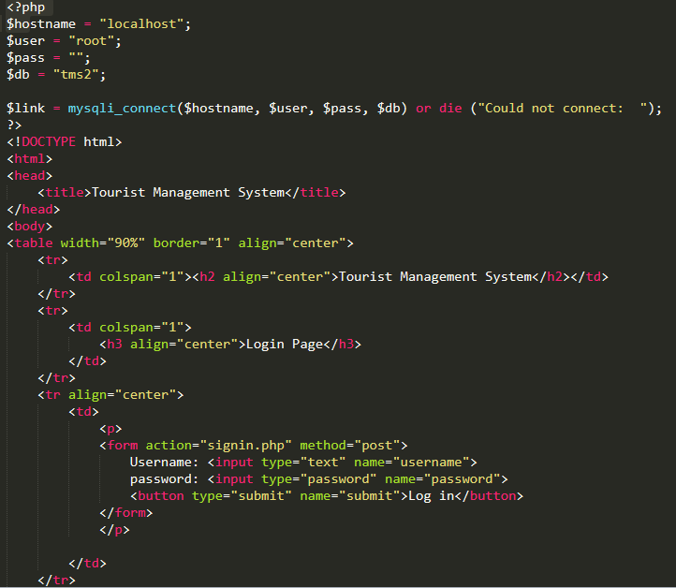

# **TECHNICAL CHALLENGES:**

The main technical challenge we face was how to connect the database with php and we came to know about it from the tutorial given by the instructor.

## **Work division:**

Saqib taught us about the working of database every problem we faced while creating this database was solved by him,

Full database is created by team work

Presentation is made by Maryam

Report is made by Ayesha

# **Conclusion:**

* Travel and tourism management simplifies the management process in travelling
* Fast processing and immediate results with high security
* Minimizing human effort and cost efficient databases
* Navigation through site is easy